


To: Members of the Southwest U.S. Kendo & Iaido Federation (SWKIF) Date: February 6, 2017
Members of the All United State Kendo Federation (AUSKF) & Invited Guests

From: Nathan Williams and Zachary Gonzales, Tournament Co-Chairmen

RE: 2017 Nabeshima Cup & Texas Open Kendo Taikai

Every two years the Dallas/Fort Worth Kendo and Iaido Kyokai hosts the Nabeshima Cup Invitational Kendo Tournament in Dallas. We are pleased to announce that the 16th Nabeshima Cup Taikai and the 9th Texas Open Kendo Taikai will be held on Saturday, April 22nd, 2017, followed by a banquet that night. In addition, we are extremely pleased to announce that Jeffrey Marsten Sensei (Kendo Kyoshi 7 dan – Former President of AUSKF) will be returning as our guest of honor.

Schedule of Events
- Friday, April 21st SWKIF Board of Directors Meeting ……………………………………….……. 6:00-9:00 pm
Seminar Conducted by our Guests of Honor …………………………………….. 6:00-9:00 pm
- Saturday, April 22nd Nabeshima Cup: (Mudansha, Yudansha, Women) ….……………………………. 9:00-3:30 pm
Texas Open Kendo Division: Yondan and above ……………………………….. 3:30-5:00 pm
Banquet …………………………………………………………………………... 7:00 pm-
- Sunday, April 23rd SWKIF Kendo Shinsa (rank promotion testing up to Yondan) …………………. 9:00 am-1:00 pm
The 2017 Nabeshima Cup Taikai will be offering four divisions: Mudansha (1 kyu and below), Yudansha (1 dan to 3 dan), and Women (3 dan and below), for ages 14 years and older. Women may choose to enter only one division: the Womens Division, Mudansha Division, or Yudansha Division. The Texas Open is open to all Yondan and above. There will be no Youth Division.
All primary activities will be held at The Greenhill School’s Phillips Gymnasium located at 4141 Spring Valley Road, Addison, TX 75001. The Saturday evening banquet will be held at the banquet room at Japan House,Plano TX. Please see attached Itinerary of Events and maps for further information.

Hotel Accommodations: We have reserved a block of rooms at the Crowne Plaza Dallas near Addsion-Galleria. Booking is first-come, first-served. The block of rooms is reserved under the group code: Nabeshima Cup at a rate of $95, $105 for a triple rate, and $115 for a quad rate(This is before tax and there is also a $10.00 parking fee) per night for a single/double standard room. Please advise your attendees to call the hotel reservations department at 972-980-8877 during regular business hours, or the 24-hour line at 800-227-6963. When calling, please specify the hotel location code ‘DALAD’. To receive the discounted rates. Group will be identified as “Nabeshima Cup” Reservations should be made by March 31st, 2017, to receive the special rate.
Crowne Plaza Dallas near Addison-Galleria
14315 Midway Rd, Addison, TX 75001
https://www.ihg.com/crowneplaza/hotels/us/en/addison/dalad/hoteldetail
Tel +1-972-934-8400 Group Code: Nabeshima Cup
Please complete and return all applicable seminar and taikai registration package materials to their correct location by April 7th, 2017. The registration for the seminar and taikai must be completed at your dojo level as a group. If you are the only participant from your dojo, please use the same registration form with yourself as the main contact. The copy of this registration package is available at www.dfwkik.org/nabeshima. Please ensure all information is complete and accurate. Cancellation for Taikai related events must be received by April 12th. There will be no refunds on registration fees if cancelled after this date.

Should you have any questions or comments, please do not hesitate to contact us at any time.
On behalf of the SWKIF and the DFWKIK,
Registration: General Contact:
Zachary Gonzales Nathan Williams
Tournament Co-Chairman Tournament Co-Chairman
Phone: 817-308-8212 972-979-2846
email: zach.t.gonzales@gmail.com

We appreciate the vendors who come to this event. However, please be advised that any products or services offered by
vendors are chosen by them and are offered without any endorsement, explicit or implied, by the DFWKIK, SWKIF or the AUSKF
***Contents/Attachments***

SEMINAR, TAIKAI, & FOOD REGISTRATION AND MAILING

- Nabeshima Cup and Texas Open Announcement Letter (Previous Page)

- Contents/Attachments and Checklist (This Page)

- Itinerary of Events

- Registration Form Instructions

- Event Waiver of Liability

- Governing Regulations

- Event Location/Map

** SHINSA MATERIAL is not attached with this Registration Package but will be available at www.dfwkik.org/nabeshima.
Please submit shinsa material to SWKIF directly.

***Checklist***

❑ Completed Registration Form (Electronic Copy) – Email to zach.t.gonzales@gmail.com

❑ Completed Registration Form (Hard Copy) – Mail to DFWKIK

❑ Every Participant’s Signed Waiver of Liability (Hard Copies) - Mail to DFWKIK

❑ One check for the Grand Total Amount Payable to “DFWKIK” - Mail to DFWKIK

SCHEDULE OF EVENTS
(Schedule Subject to Change)

Friday, April 21st, 2017

6:00 – 9:00 PM SWKIF Board of Directors Meeting – Crowne Plaza Conference room
6:00 – 9:00 PM Seminar – The Greenhill School Phillips Gymnasium

Saturday, April 22nd, 2017 – The Greenhill School Phillips Gymnasium

8:00 – 8:45 AM Registration of Competitors; Shinai weigh-in
8:30 AM Shinpan Meeting in Phillips Gymnasium
9:00 AM Opening Ceremony
9:15 AM Nabeshima Cup, Division Matches
Women – Mudansha to Sandan for age 16+
Mudansha – 1st Kyu and below for age 14+
Yudansha – Shodan to Sandan
1:00 PM Lunch

1:45 PM Nabeshima Cup, Division Matches
Women – Mudansha to Sandan for age 16+
Mudansha – 1st Kyu and below
Yudansha – Shodan to Sandan
3:00 PM Nabeshima Cup Semifinals and Finals
Women – Mudansha to Sandan for age 16+
Mudansha – 1st Kyu and below
Yudansha – Shodan to Sandan
3:30 PM Texas Open Kendo Tournament
Yudansha – Yondan and above

4:45 PM Awards Presentation & Closing Ceremony
5:00 PM Open Practice (Time Permitting)

Saturday, April 22nd, 2017 – Japan House Restaurant

7:00 PM Dinner Banquet at Japan House Restaurant
Dinner starts promptly at 7:30pm

~9:30 PM Second Dojo at Mr. Sushi

Sunday, April 23rd, 2017 – Shinsa at The Greenhill School Phillips Gymnasium

8:00 AM Registration
9:00 AM Kendo Promotional Exams Start

Godo-Keiko after Testing (Time Permitting)

*All schedules are subject to change.

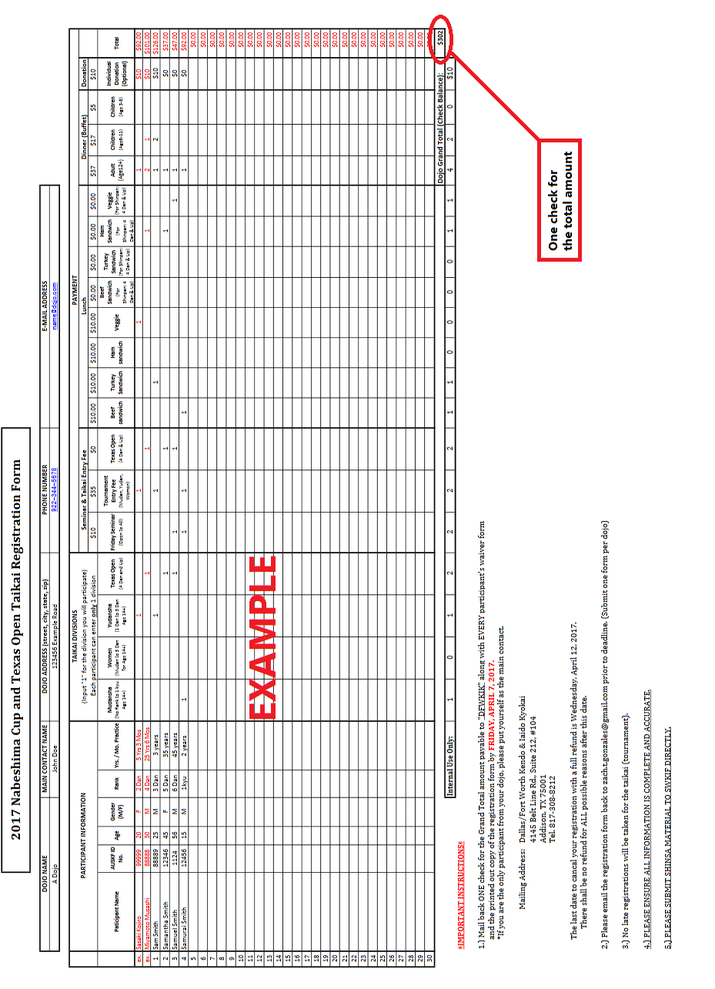

WAIVER OF LIABILITY
FOR PARTICIPATION OF EVENTS IN THE
2017 NABESHIMA CUP TAIKAI AND ALL ASSOCIATED ACTIVITIES

I, the below signed Participant, intending to be legally bound, do hereby, for myself, my heirs, assigns, executors and administrators, waive, release, and forever discharge any claims for damages, illness, injuries and/or death which may hereafter accrue to me against the Dallas/Fort Worth Kendo & Iaido Kyokai, the Southwest Kendo & Iaido Federation, The Greenhill School, their members, employees, instructors, agents, invited senseis and participants in the 2017 Nabeshima Cup Taikai, Mudansha Division Taikai, Yudansha Division Taikai, Women Division Taikai, Texas Open Taikai and related activities for any and all damages which may be sustained or suffered by me in connection with, in association with, travel to or from or participation in the 2017 Nabeshima Cup Taikai, Mudansha Division Taikai, Yudansha Division Taikai, Women Division Taikai, Texas Open Taikai and related activities. I further agree to indemnify and hold harmless the Dallas/Fort Worth Kendo & Iaido Kyokai, the Southwest Kendo & Iaido Federation, The Greenhill School, their members, employees, instructors, agents, invited senseis and participants in the 2017 Nabeshima Cup Taikai, Mudansha Division Taikai, Yudansha Division Taikai, Women Division Taikai, Texas Open Taikai and related activities for any claims I may have outlined herein.

Participant:

________________________________________________________________ Date: ________________

*Parent or Legal Guardian:

________________________________________________________________ Date: ________________

*(Note: Parent or Legal Guardian must sign if the Participant is under the age of eighteen years old.)

GOVERNING REGULATIONS
2017 NABESHIMA CUP & TEXAS OPEN KENDO TAIKAIS

- The Nabeshima Cup Invitational Kendo Tournament is a set of individual tournaments comprised of 3 brackets held for kenshi holding a rank of Sandan or lower ( Women, Mudansha, and Yudansha) and the Texas Open, an individual tournament held for all kenshi holding a rank of Yondan or higher. The Nabeshima Cup Invitational Kendo Tournament is designed to promote friendship among fellow kenshi and to allow kenshi to gain experience in shiai kendo.

- Shinpan duty- All participants of the Texas Open and other attending kenshi of Yondan rank or higher will be asked to be shinpan for the Nabeshima Cup brackets. All senior kenshi will be asked to be shinpan for the Texas Open, and shinpan needs may require that some participants in the Texas Open also shinpan. Shinpan dress code will be official FIK taikai uniform.

- The Nabeshima Cup Invitational Kendo Tournaments and The Texas Open Kendo Tournament will be formatted as a Single Elimination tournaments based on the number of participants.

- Matches:
- All matches are Sanbon-shobu (3 point match). In the event of a forfeit, the winner is awarded 2 points.
- All Nabeshima Cup matches will be 3 minutes in length with a 2 minute encho. In the event of a tie in scoring after encho, a hantei judgment will be issued to determine the match winner.
- Texas Open matches will be 4 minutes with unlimited encho.
- All Semi-Final and Final matches will be 5 minutes in length with unlimited encho and will occur
after all divisional matches leading up the semi-final and final matches have concluded.

- Seeding Brackets:
- Youth (ages 14-17) and women partcipants may choose to enter either Mudansha or Yudansha Divisions depending on rank and skill, but will only be allowed to enter a single bracket.
- Participants of the Nabeshima Cup brackets will be seeded according to rank, age, and dojo. Efforts will be made to avoid seeding competitors of the same dojo in the same brackets.
- Seeding for the Texas Open will be conducted by draw.
- Competitors will be assigned a Court and Competitor number based on their seeded position.

- All equipment, including shinai, must adhere to regulation sizes, weights, and characteristics established by the International Kendo Federation. Shinai must be inspected, weighed and approved prior to the taikai opening. Competitors observed using unapproved shinai during the taikai risk disqualification.

- All decisions of the judges are final. All other Governing Regulations will follow the rules and guidance of the International Kendo Federation.

- Two perpetual trophy awards (Nabeshima Cup) will be awarded to the winners; one for the Mudansha Division and one for the Yudansha Division. Individual trophies for all divisional winners, 2nd and 3rd place finishers, including Kantosho (Fighting Spirit) recipients for each bracket, will also be awarded.

- The Nabeshima Cups are perpetual trophies awarded to the winners. The Cups are the property of the Dallas/Ft. Worth Kendo & Iaido Kyokai, and must be returned to the organization when the next Nabeshima Cup event is held, as the winners are always invited back to defend his or her title.

Copyright © 2017 DFWKIK

Regulations for Use of One Shinai

 | gender | Grade School |  |  | Junior High School | High School | College - Adult
length | male  female | 99cm  maximum | 105cm  maximum | 111cm  maximum | 114cm  maximum | 117cm  maximum | 120cm  maximum
weight | male | 260g  minimum | 280g  minimum | 370g  minimum | 440g  minimum | 480g  minimum | 510g  minimum
weight | female | 260g  minimum | 280g  minimum | 370g  minimum | 400g  minimum | 420g  minimum | 440g  minimum
Diameter  of  sakigawa | male |  |  |  | 25mm  minimum | 26mm  minimum | 26mm  minimum
Diameter  of  sakigawa | female |  |  |  | 24mm  minimum | 25mm  minimum | 25mm  minimum
size |  | 3.2 | 3.4 | 3.6 | 3.7 | 3.8 | 3.9

Regulations for Use of Two Shinai
 |  | long sword | short sword
length | male  female | 114cm  maximum | 62cm  maximum
weight | male | 440g  minimum | 280-300g
weight | female | 400g  minimum | 250-280g
diameter  of  sakigawa | male | 25mm  minimum | 24mm  minimum
diameter  of  sakigawa | female | 24mm  minimum | 24mm  minimum
size |  | 3.7

Measurements for the Sakigawa
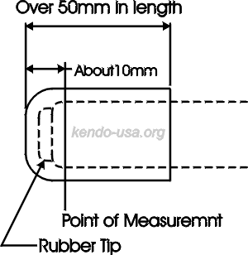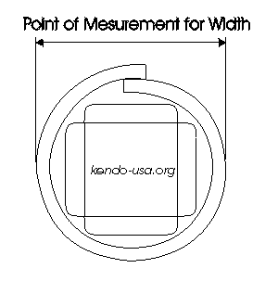Copyright © 2002 www.kendo-usa.org
Crowne Plaza to Japan House (Banquet location)
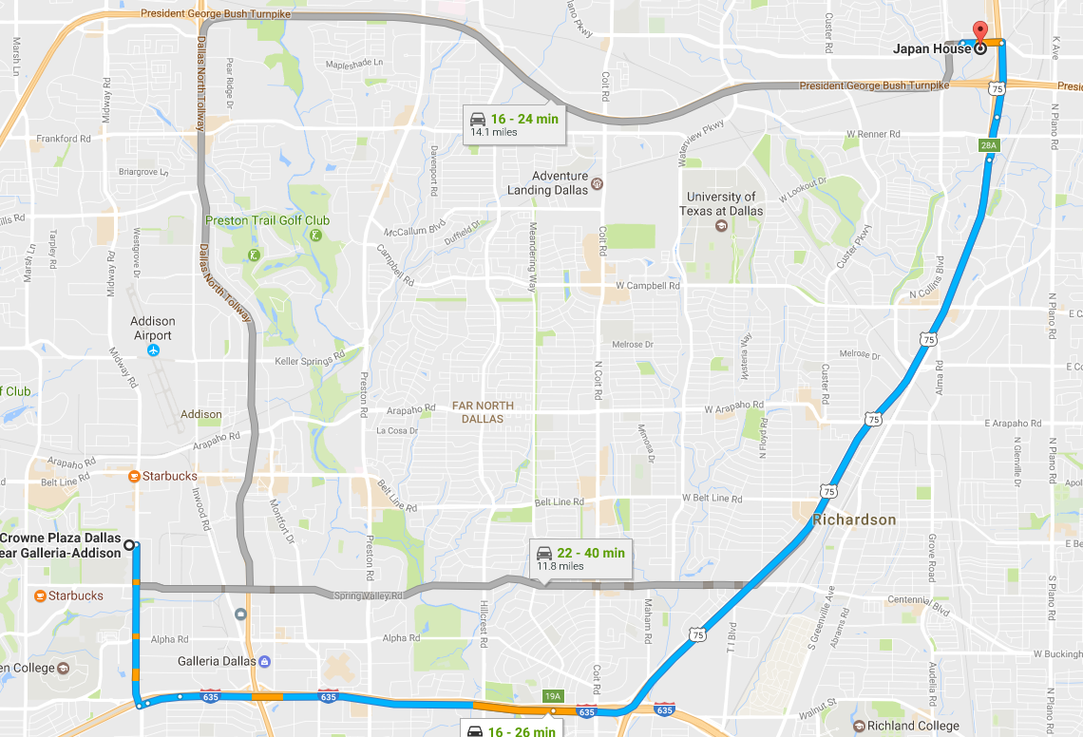
N
Directions:

14315 Midway Rd
Addison, TX 75001

Head south on Midway Rd toward Hornet Rd

Use the left 2 lanes to turn left onto Interstate 635 Service Rd.

Use the left lane to take the ramp onto I-635 E
Continue on I-635E

Use the right two lanes to take Exit 19A to Merge onto US-75N toward McKinney

Take exit 28A toward Plano Parkway

Merge onto N Central Expy

Use the left 2 lanes to turn left onto E Plano Pkwy

Make a U-turn at Collin Creek Mall

Destination will be on the right

300 W Plano Pkwy
Plano, TX 75075

Hotel, Banquet and Second Dojo Addresses
Crowne Plaza Dallas near Galleria-Addison
14315 Midway Rd,
Addison, TX75001
Tel. +1-972-980-8877
https://www.ihg.com/crowneplaza/hotels/us/en/addison/dalad/hoteldetail
Japan House Restaurant
300 W Plano Pkwy,
Plano, TX 75075
http://www.japanhouseus.com/
Second Dojo-Mr. Sushi
4860 Belt Line Road,
Addison, TX75001
http://www.mrsushidallas.com

