


To: Members of the Southwest U.S. Kendo & Iaido Federation (SWKIF) Date:August 16, 2011
Members of the All United States Kendo Federation (AUSKF)
Invited Guests

From: Michio Kajitani and An Giang, Arkansas Kendo Club

Re: SWKIF - 2011 Fall Seminar

We are pleased to announce the first SWKIF sponsored seminar in Little Rock, AR. The seminar will allow kenshi from all around to meet and practice together in the Natural State. The seminar will be held focusing on tournament skills and judging . The seminar starts from the evening of Friday October 28 through all day Saturday October 29, 2011, with a buffet banquet afterwards. A shinsa, testing to 3-dan, will occur on the Sunday, October 30, 2011.
We are extremely pleased to invite Jeffrey Marsten sensei (Kendo Kyoshi 7 dan – Forward President of AUSKF) as the guest of honor. Everyone is invited to attend and participate in this event.

Itinerary

- Friday, October 28 SWKIF Board of Directors Meeting 6:30-9:30pm
Evening Seminar with Guest Sensei 6:30-9:30pm
- Saturday, October 29 All-Day Seminar with Guest Sensei 9:00-5:00pm
Banquet Dinner 7:30pm –
- Sunday, October 30 SWKIF Kendo Shinsa (up to Sandan) 9:00-12:00pm

All seminar events will be held at the Meyer Student Pavilion at Pulaski Academy School, located at 12701 Hinson Road in Little Rock, AR, 72212. The Saturday banquet will be held at the restaurant Tokyo House which is directly across the street from the selected hotel listed below. See attached itinerary and maps for more information.

Hotel Accommodations

We have reserved a block of rooms at the Ramada Limited hotel. Booking is first come, first served. The block of rooms are reserved under the code KENDO at a special rate of $66+tax per night for a standard single/double room. Reservations should be made by October 1, 2011, or as soon as possible to ensure availability.

Ramada Limited
8 Shackleford Drive
Little Rock, AR 72211
501-221-7666
Code: KENDO

Please complete and return all seminar registration materials to their correct location by the specified deadlines. Please visit www.arkansas-kendo.com for copies of this registration package.

Questions, comments or concerns may be sent to any of us at any time.

On behalf of the SWKIF and Arkansas Kendo,

Michio Kajitani An Giang Arkansas Kendo Club
501-416-3805 501-831-2894 16401 Chenal Valley Dr. #5102
kmichio@hotmail.com avgiang@yahoo.com Little Rock, AR 72221

www.arkansas-kendo.com
PACKET CONTENTS

- Open Letter and Invitation (Previous Page)

- Packet Contents (Current Page)

- Itinerary of Events

- Seminar & Food Registration Form

- Event Waiver of Liability

- Event Maps and Location

SHINSA MATERIALS will be provided directly by SWKIF VP of Promotions.

ITINERARY OF EVENTS

Friday, October 28, 2011

5:30 – 6:30 am Seminar Check-in at Meyer Student Pavilion, Pulaski Academy

6:30 – 9:30 pm SWKIF Board of Directors Meeting at Ramada Limited Hotel

6:30 – 9:30 pm Seminar conducted by Marsten Sensei at Meyer Student Pavilion

Saturday, October 29, 2011

8:00 am Seminar Check-in at Meyer Student Pavilion, Pulaski Academy

9:00 am Opening & Morning Seminar

12:00 pm Lunch

1:00 pm Afternoon Seminar

4:45 pm Closing

5:00 pm Open Practice (until 7:00 pm)

7:30 pm Dinner Banquet at Tokyo House

Sunday, October 30, 2011

8:00 am Shinsa Registration & Setup

9:00 am Kendo Promotional Exams

12:00 pm Open Floor (until 2:00 pm)

SEMINAR REGISTRATION FORM

Arkansas Kendo Club
2011 SWKIF Fall Seminar

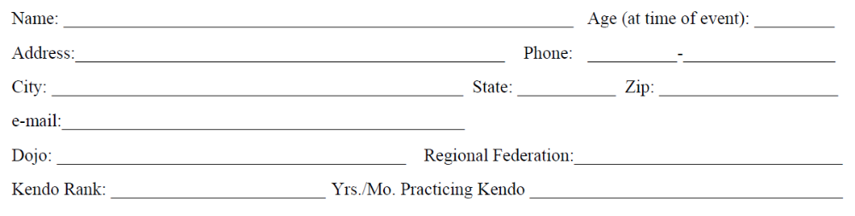
Saturday Lunch

TBD

Saturday Dinner

Japanese and Sushi buffet style dinner. Price includes food, non-alcoholic drinks, taxes, and gratuity.

Please mark the appropriate items and fill in the total amounts.

Seminar ($40 for Friday & Saturday) $_______

Saturday Lunch ($10 x ____ persons) $_______

Saturday Dinner ($30 x ____ persons) $_______

Donations $_______

GRAND TOTAL $ __________

Note: Sunday Lunch – Not Provided

Please return this registration form, waiver of liability and check payable to “Arkansas Kendo Club” by SATURDAY, OCTOBER 1, 2011.

Cancellation Policy: October 8 is last day to cancel participation with full refund of registration and food.
No refunds will be made for cancellations afterwards unless entire event is cancelled.

Submit all seminar registration forms and payment to:

Arkansas Kendo Club
C/o Michio Kajitani
16401 Chenal Valley Dr. #5102
Little Rock, AR 72223

PLEASE SUBMIT ALL SHINSA REGISTRATION TO SWKIF DIRECTLY.

WAIVER OF LIABILITY

FOR PARTICIPATION OF EVENTS IN THE 2011 SWKIF FALL
SEMINAR AT LITTLE ROCK, ARKANSAS

I, the below signed Participant, intending to be legally bound, do hereby, for myself, my heirs, assigns, executors and administrators, waive, release, and forever discharge any claims for damages, illness, injuries and/or death which may hereafter accrue to me against the Arkansas Kendo Club, the Southwest Kendo & Iaido Federation, Pulaski Academy, their members, employees, instructors, agents, invited sensei and participants in the 2011 SWKIF Fall Seminar and related activities for any and all damages which may be sustained or suffered by me in connection with, in association with, travel to or from or participation in the 2011 SWKIF Fall Seminar and related activities. I further agree to indemnify and hold harmless the Arkansas Kendo Club, the Southwest Kendo & Iaido Federation, Pulaski Academy, their members, employees, instructors, agents, invited sensei and participants in the 2011 SWKIF Fall Seminar for any claims I may have outlined herein.

Participant:

_________________________________________________________________ Date: ___________________
Signature Printed

Parent or Legal Guardian (required if under 18)

_________________________________________________________________ Date: ___________________
Signature Printed

MAPS AND LOCATION

A – Ramada Limited B – Meyer Student Pavilion, Pulaski Academy
8 Shackleford Drive 12701 Hinson Road
Little Rock, AR 72211 Little Rock, AR 72212

C – Tokyo House
11 Shackleford Drive
Little Rock, AR 72211

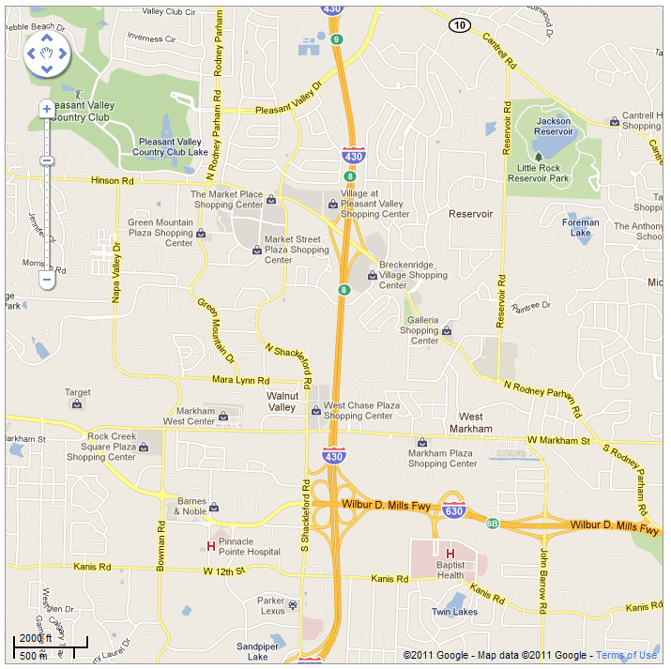
B
C
A

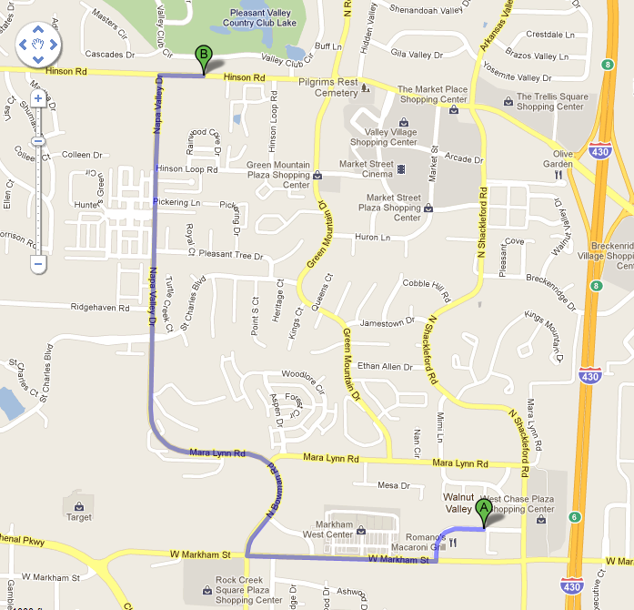
Route from Hotel to Seminar

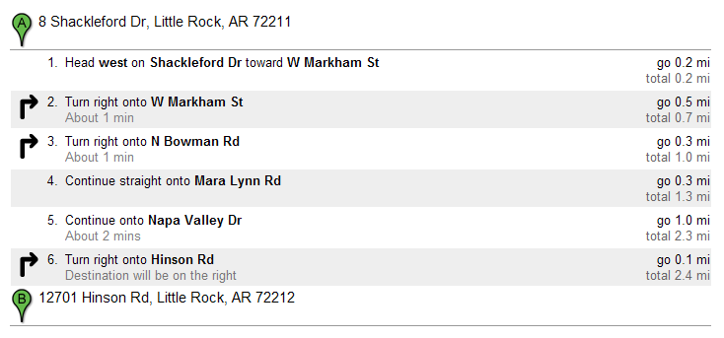

Route from Interstate Highways to Hotel

Southbound on I-430 Westbound on I-630 (from airport)


