SHIN SOU FU KAN DOJO
ABOUT THE EVENT
It’s with great pleasure, to announce SWKIF team practice, held in Tulsa Oklahoma. The SWKIF Team will be conducting a Two-day Training Kendo seminar. We are grateful to have such compassionate and strong teachers willing to go out of their way to raise our level up.

This event is open to any level kendoka, and to dojo interested in participating. Please let us know if the cost of the seminar is an issue, we can work something out. This is a non-profit event, so the fee’s are only going to be used to pay for the practice space and cover the visiting sensei meals and any additional travel expenses.

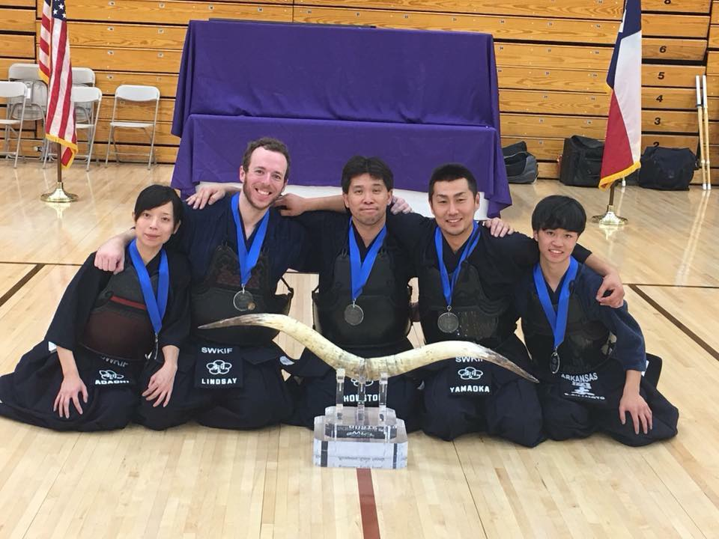
Visiting instructors
  - Takuro Yamaoka
  - Makiko Adachi

LOCATION & TIMES
Feb 24, Saturday
Charles Schusterman Jewish Community Center
2021 E 71st St, Tulsa, OK 74136
Time 12:00-4:00PM

Feb 35, Sunday
Charles Schusterman Jewish Community Center
2021 E 71st St, Tulsa, OK 74136
Time 9:00-11:00AM

HOME STAY
Please let us know if you need a home stay, we can arrange home stays with Tulsa Kendo Dojo members if cost is an issue.

EVENT DUES:
DUE 2/19/18
2-day attendance: $20.00
Please Write any money orders or Checks to:
Michael Lindsay
3533 South Norfolk Ave Tulsa OK, 74105
Paypal: Michael@tulsakendo.com
Late payments are an additional +$5 to the above.
No Late payments will be accepted after Febuary 23, 2018
Please Send the Waiver form with payment

WAIVER OF LIABILITY
FOR PARTICIPATION OF EVENTS IN THE SWKIF TEAM PRACTICE 2018

I, the below signed Participant, intending to be legally bound, do hereby, for myself, my heirs, assigns, executors and administrators, waive, release, and forever discharge any claims for damages, illness, injuries and/or death which may hereafter accrue to me against the Tulsa Kendo Shin Sou Fu Kan Dojo, Charles Shusterman Jewish Community Center, The City of Tulsa, their members, employees, instructors, agents, invited sensei, and participants in the SWKIF TEAM PRACTICE 2018 in Tulsa, OK for any and all damages which may be sustained or suffered by me in connection with, in association with, travel to or from or participation in the SWKIF TEAM PRACTICE. I further agree to indemnify and hold harmless the Shin Sou Fu Kan Dojo, the Shi Ku Kai Dojo, Charles Shusterman Jewish Community Center, The City of Tulsa, their members, employees, instructors, agents, invited sensei, and participants in the SWKIF TEAM PRACTICE 2018 in Tulsa, OK for any claims I may have outlined here in.

Participant:

________________________________________________________________ Date: ________________

*Parent or Legal Guardian:

________________________________________________________________ Date: _______________

*(Note: Parent or Legal Guardian must sign is the Participant is under the age of eighteen years old)

