March 1, 2019

From: Nathan Williams and Simon Martinez, Tournament Co-Chairmen

Subject: 2019 Nabeshima Cup Taikai & Texas Open Taikai

To: Members of Southwest U.S. Kendo & Iaido Federation (SWKIF)
Members of All United State Kendo Federation (AUSKF) & Invited Guests

Greetings,

Dallas/Fort Worth Kendo and Iaido Kyokai is pleased to announce that the 17th Nabeshima Cup Taikai and the 10th Texas Open Kendo Taikai will be held on Saturday, April 27th, 2019 in Dallas, Texas, followed by a banquet that evening. In addition, we are extremely pleased to announce that Jeffrey Marsten Sensei (Kendo Kyoshi 7 Dan – Former President of AUSKF) will be returning as our guest and Shinpan-Cho as well as Kiyoshi and Chizuko Abe from Japan as guests of honor. Abe Sensei is a former instructor at DFWKIK and the namesake of one Kantosho Award at this Taikai.

The 2019 Nabeshima Cup Taikai will be offering four divisions: Mudansha (1 Kyu and below), Yudansha (1 Dan to 3 Dan), and Women (3 Dan and below), for ages 14 years and older. Women may choose to enter only one division: the Women’s Division, Mudansha Division, or Yudansha Division. The Texas Open is open to all Yondan and above.

All primary activities will be held at The Greenhill School’s Phillips Gymnasium located at 4141 Spring Valley Road, Addison, TX 75001. (Please use the Midway Rd. and Hornet Drive Entrance)
The Saturday evening banquet will be held at Ten50 BBQ, in Richardson TX. Please see attached Itinerary of Events and maps for further information
.
Hotel Accommodations: We have reserved a block of rooms at the Hilton @ Lincoln Centre, booking is first-come, first-served. The block of rooms is reserved under the group code: SWKIF at a rate of $100.00, $115.00 triple/quad rate without tax, this rate includes Breakfast. The Hotel charges a parking fee of $8.00 per day. Please advise your attendees to call the hotel reservations department at 972-934-8400 during regular business hours, or the 24-hour line at 1-800-445-8667. When calling, please specify the hotel location code ‘SWKIF’. To receive the discounted rates. Group will be identified as “SWKIF” Reservations should be made by April 5th 2019, to receive the group rate.
Hilton @ Lincoln Centre
5410 LBJ Freeway, Dallas, TX 75240
https://book.passkey.com/gt/217272446?gtid=b3d31dfb5f0c4486814bb6b9c2b546dc
Tel +1-800-445-8667 Group Code: SWKIF (needed when reservations are made via central reservation line)
Please complete and return all applicable seminar and taikai registration package materials to their correct location by April 12th, 2019. The registration for the seminar and taikai must be completed at your dojo as a group. If you are the only participant from your dojo, please use the same registration form with yourself as the main contact. The copy of this registration package is available at www.dfwkik.org. Please ensure all information is complete and accurate. Cancellation for Taikai related events must be received by April 17th. There will be no refunds on registration fees if cancelled after this date.

Should you have any questions or comments, please do not hesitate to contact us at any time.

On behalf of the SWKIF and the DFWKIK,

Registration: General Contact:
Nathan Williams Simon Martinez
Tournament Co-Chairman Tournament Co-Chairman
Phone: 972-979-2846 214-629-5402
email: nate88williams@gmail.com email: dfwkik.historian@gmail.com

We appreciate the vendors who come to this event. However, please be advised that any products or services offered by
vendors are chosen by them and are offered without any endorsement, explicit or implied, by the DFWKIK, SWKIF or the AUSKF

Itinerary of Events

- Friday, April 26th

6:00pm - 9:00 PM SWKIF Board of Directors Meeting
Hilton @ Lincoln Centre In the Conservatory

5:00pm - 6:00 PM Registration and Shinai Check-In
6:00pm - 8:00 PM Seminar @ Greenhill Cox Gymnasium

- Saturday, April 27th:

17th Nabeshima Cup Taikai and Texas Open Taikai

8:00 – 8:45 AM Registration of Competitors; Shinai weigh-in
8:30 AM Shinpan Meeting in Phillips Gymnasium
9:00 AM Opening Ceremony
9:15 AM Nabeshima Cup, Division Matches

Women – Mudansha to Sandan for age 14+
Mudansha – 1st Kyu and below
Yudansha – Shodan to Sandan

1:00 PM Lunch

1:45 PM Nabeshima Cup, Division Matches
Women – Mudansha to Sandan for age 14+
Mudansha – 1st Kyu and below
Yudansha – Shodan to Sandan

3:00 PM Nabeshima Cup & Texas Open Semifinals and Finals
Women – Mudansha to Sandan for age 14+
Mudansha – 1st Kyu and below
Yudansha – Shodan to Sandan

4:00 PM Texas Open Kendo Tournament
Yudansha – Yondan and above

4:45 PM Awards Presentation

5:00 PM Closing Ceremony

8:00 PM - 10:00 PM Sayonara Banquet @
TEN50 BBQ
1050 N Central Expy
Richardson, TX 75080

- Sunday, April 28th

SWKIF Kendo Shinsa (Rank promotion testing up to Yondan)

8:30AM Registration

9:00AM -12:00 PM Testing:

12:00 – 1:30 PM Godo Keiko

***Contents/Attachments***

SEMINAR, TAIKAI, & FOOD REGISTRATION AND MAILING

Nabeshima Cup Taikai and Texas Open Announcement Letter (Previous Page)

Contents/Attachments and Checklist (This Page)

Itinerary of Events

Registration Form Instructions

Event Waiver of Liability

Governing Regulations

Event Location/Map

** SHINSA MATERIAL is not attached with this Registration Package but will be available at
www.swkif.org

Please submit Shinsa material to SWKIF directly.

***Checklist***

Completed Registration Form (Electronic Copy) – Email to nate88williams@gmail.com

Completed Registration Form (Hard Copy) – Mail to DFWKIK

All Participant’s Signed Waiver of Liability (Hard Copies) - Mail to DFWKIK

One check for the Grand Total Amount Payable to “DFWKIK” - Mail to DFWKIK

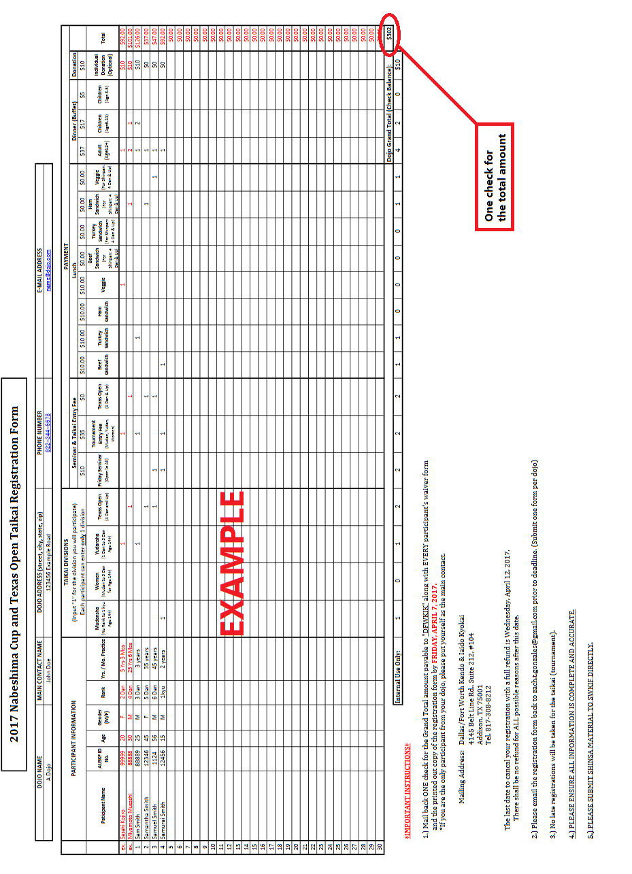

WAIVER OF LIABILITY
FOR PARTICIPATION OF EVENTS IN THE
2019 NABESHIMA TAIKAI AND ALL ASSOCIATED ACTIVITIES

I, the below signed Participant, intending to be legally bound, do hereby, for myself, my heirs, assigns, executors and administrators, waive, release, and forever discharge any claims for damages, illness, injuries and/or death which may hereafter accrue to me against the Dallas/Fort Worth Kendo & Iaido Kyokai, the Southwest Kendo & Iaido Federation, The Greenhill School, their members, employees, instructors, agents, invited Sensei and participants in the 2019 Nabeshima Cup Taikai, Mudansha Division, Yudansha Division, Women Division, Texas Open Taikai and related activities for any and all damages which may be sustained or suffered by me in connection with, in association with, travel to or from or participation in the 2019 Nabeshima Taikai, Mudansha Division, Yudansha Division, Women Division, Texas Open Taikai and related activities. I further agree to indemnify and hold harmless the Dallas/Fort Worth Kendo & Iaido Kyokai, the Southwest Kendo & Iaido Federation, The Greenhill School, their members, employees, instructors, agents, invited Sensei and participants in the 2019 Nabeshima Cup Taikai, Mudansha Division, Yudansha Division, Women Division, Texas Open Taikai and related activities for any claims I may have outlined herein. DFWKIK retains all rights to publication of photos.

Participant:

________________________________________________________________ Date: ________________

*Parent or Legal Guardian:

________________________________________________________________ Date: ________________

*(Note: Parent or Legal Guardian must sign if the Participant is under the age of eighteen years old.)

GOVERNING REGULATIONS
2019 NABESHIMA CUP & TEXAS OPEN KENDO TAIKAIS

- The Nabeshima Cup Invitational Kendo Tournament is a set of individual tournaments comprised of 3 brackets held for Kenshi holding a rank of Sandan or lower (Women, Mudansha, and Yudansha) and the Texas Open, an individual tournament held for all Kenshi holding a rank of Yondan or higher. The Nabeshima Cup Invitational Kendo Tournament is designed to promote friendship among fellow Kenshi and to allow Kenshi to gain experience in Shiai Kendo.

- Shinpan duty - All participants of the Texas Open and other attending kenshi of Yondan rank will be asked to be Shinpan for the Nabeshima Cup brackets in the registration package. Though not mandatory, it is recommended that all YonDan sign up for Shinpan duty. All GoDan and higher will be asked to be Shinpan for the Texas Open. Shinpan dress code will be official FIK Taikai uniform.

- The Nabeshima Cup Invitational Kendo Tournaments and The Texas Open Kendo Tournament will be formatted as a Single Elimination tournament based on the number of participants.

IV. Matches:
a) All matches are Sanbon-shobu (3-point match). In the event of a forfeit, the winner is awarded 2 points.
b) All Nabeshima Cup matches will be 3 minutes in length with a 2-minute Encho. In the event of a tie in scoring after Encho, a Hantei judgment will be issued to determine the match winner.
c) Texas Open matches will be 4 minutes with unlimited Encho.
d) All Semi-Final and Final matches will be 5 minutes in length with unlimited Encho and will occur
after all divisional matches leading up the semi-final and final matches have concluded.

V. Seeding Brackets:
a) Women participants may choose to enter either Womens, Mudansha, or Yudansha Divisions depending on rank and skill, but will only be allowed to enter a single bracket.
b) Participants in all brackets will be seeded according to rank, age, and dojo. Efforts will be made to avoid seeding competitors of the same dojo in the same brackets.
c) Competitors will be assigned a Court and Competitor number based on their seeded position.

VI. All equipment, including shinai, must adhere to regulation sizes, weights, and characteristics established by the International Kendo Federation. Shinai must be inspected, weighed and approved prior to the taikai opening. Competitors observed using unapproved shinai during the taikai risk disqualification.

VII. All decisions of the judges are final. All other Governing Regulations will follow the rules and guidance of the International Kendo Federation.

VIII. Two perpetual trophy awards (Nabeshima Cup) will be awarded to the winners; one for the Mudansha Division and one for the Yudansha Division. Individual medals for all divisional winners, 2nd and 3rd place finishers, including Kantosho (Fighting Spirit) recipients for each bracket, will also be awarded.

IX. The Nabeshima Cups are perpetual trophies awarded to the winners. The Cups are the property of the Dallas/Ft. Worth Kendo & Iaido Kyokai, and must be returned to the organization prior to the next Nabeshima Cup event is held, as the winners are always invited back to defend his or her title.

Copyright © 2019 DFWKIK

Regulations for Use of One Shinai

 | gender | Grade School |  |  | Junior High School | High School | College - Adult
length | male  female | 99cm  maximum | 105cm  maximum | 111cm  maximum | 114cm  maximum | 117cm  maximum | 120cm  maximum
weight | male | 260g  minimum | 280g  minimum | 370g  minimum | 440g  minimum | 480g  minimum | 510g  minimum
 | female |  |  |  | 400g  minimum | 420g  minimum | 440g  minimum
Diameter  of  sakigawa | male |  |  |  | 25mm  minimum | 26mm  minimum | 26mm  minimum
 | female |  |  |  | 24mm  minimum | 25mm  minimum | 25mm  minimum
size |  | 3.2 | 3.4 | 3.6 | 3.7 | 3.8 | 3.9

Regulations for Use of Two Shinai
 |  | long sword | short sword
length | male  female | 114cm  maximum | 62cm  maximum
weight | male | 440g  minimum | 280-300g
 | female | 400g  minimum | 250-280g
diameter  of  sakigawa | male | 25mm  minimum | 24mm  minimum
 | female | 24mm  minimum | 24mm  minimum
size |  | 3.7

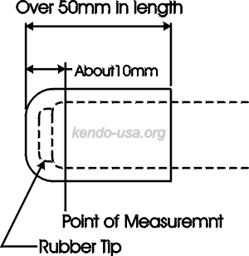
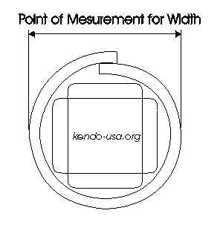
Measurements for the Sakigawa
Copyright © 2002 www.kendo-usa.org

Greenhill School
4141 Spring Valley Rd.
Addison TX 75001
(Please use the Midway Rd & Hornet Rd Entrance)

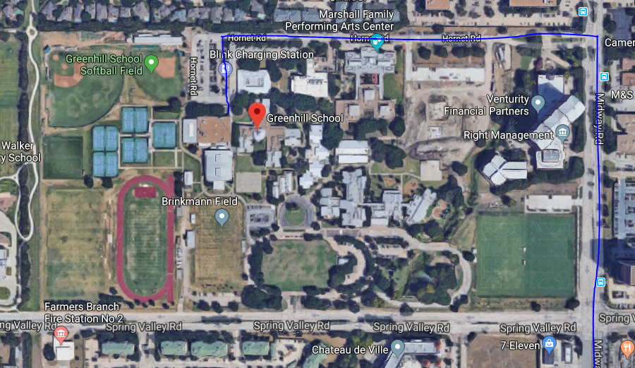

Hilton @ Lincoln Centre
5410 Lyndon B Johnson Fwy
Dallas, TX 75240