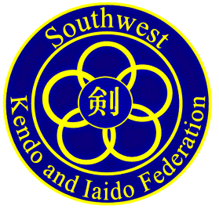

Date: Feb 20, 2018

To: Southwest U.S. Kendo & Iaido Federation and AUSKF affiliate federations

From: Ito Dojo

RE: 2018 Tsutomu Ito Cup - Team Taikai
2018 Tsutomu Ito Women’s Team Taikai
2018 SWKIF Spring Kendo seminar and shinsa

Ito Dojo is proud to be hosting the 2018 Tsutomu Ito Cup Team Taikai, Women’s Team Taikai and SWKIF Seminar and Shinsa.

Included in this package are the following:
- Itinerary of Events
- Seminar Registration Form
- Waiver of Liability
- Hotel Info, driving directions and maps

Kendo testing application materials/payments will be sent separately to the SWKIF VP of Promotions.

Registration and Payment Deadline: April 9th, 2018
No refunds will be granted after April 13th 2018.

All competitors must be at least 16 years old.

All minors must have both their Parent/Guardian and Sensei Signatures to enter competition.

Please complete all applicable materials and return them to: Thor Metzinger

Thor Metzinger
15290 Arapahoe Drive
Golden Colorado 80403

720-480-9749 (c)

Please contact us if you have any questions or comments. We are looking forward to seeing everyone in Denver.

Flights: We recommend everyone fly in early on Friday. Late afternoon arrivals will place you into Denver’s massive rush hour. This will greatly increase your travel time to the hotel & seminars.

Itinerary of Events
Note: Events will begin at the times specified. Allow time in advance for travel & preparation.

Event Locations
Standley Lake High School: 9300 W.104th Ave, Westminster CO 80021
Cinzetti’s. Northglenn Mall Shopping Center, 281 W 104th Ave, Northglenn, CO 80234
Mariott Westminister: 7000 Church Ranch Blvd, Westminister CO 80021

Friday, April 27th
5:30 PM– 6:30 PM | ITO CUP Registration Dojo Packet Pickup - Shinai Check in | Standley Lake HS
6:30 PM – 8:00 PM | Kendo Seminar | Standley Lake HS
6:00 PM – 8:00 PM | SWKIF Board Meeting | Mariott Westminster
Saturday, April 28th
7:00am – 8:00am | Team Check-in, Shinai Safety Check-in | Standley Lake HS
8:30 am – 9:15am | Opening Ceremony & Demonstration | Standley Lake HS
9:30 am – 11:00 am | Tsutomu Ito Women’s Team Tournament  Round Robin Rounds up to Final** | Standley Lake HS
11:00am – 12:00pm | Tsutomu Ito CUP--- Round Robin Matches Begin** | Standley Lake HS
**ITO CUP Round Robin Matches will begin IMMEDIATELY upon court availability following Women’s Tournament Rounds.
11:30 am | Lunches arrive for Competitors & Shinpan | Standley Lake HS
12:00 – 12:30 pm | Shinpan Lunch Break*  A special lunch will be provided for all shinpan. | Standley Lake HS
Everyone is encouraged to eat lunch at their leisure to avoid a lunch rush.
12:40 pm – 4:30 pm | ITO CUP Tournament Rounds up to Finals.  Court A:  Tsutomu Ito Women’s Team Taikai FINAL  Tsutomu Ito Cup FINAL | Standley Lake HS
4:30 pm – 5:00 pm | Award Ceremony and Closing Remarks | Standley Lake HS
7:00 pm – 9:00 pm | Celebration Banquet | Cinzetti’s
Sunday April 29th
8:00 am – 8:45 am | Registration – Check in | Standley Lake HS
9:00 am – 12pm | Kendo examinations | Standley Lake HS
Godogeiko following the conclusion of Shinsa if time permits — 2pm Closure of Facility

Dojo Representative Responsibilities

All competitors MUST hold active memberships in AUSKF in order to register in the tournaments.
No Exceptions.

Collect all Registration information from all competitors & all attendees from your dojo.
(Women entered in both Women’s Team, and Ito Cup Team need to only pay one registration fee)

Enter all Dojo information & selections on registration spreadsheet

Collect all fees- Registration, Lunches, Dinners, Shirts.

Confirm all T-shirt size selections - Enter shirts size selections by 3/30/18.
- Please no individual orders. Please enter all size orders for the dojo at the same time.
- List dojo name in comment field.
- All dojos are committed to T-shirt orders by 3/30/18.
- No extra shirts will be available at the event.

Write a single check for all registration fees, lunches, dinners & shirt payments as a single check
payable to Thor Metzinger

Mail Hardcopies of all registration forms & Payment to:

Thor Metzinger
15290 Arapahoe Drive
Golden CO 80403

Payments must be received by April 9th 2018

EMAIL – Completed Registration Spreadsheet to thor@itodojo.com

SHIRT Order Size Selections – CRITICAL EARLY DEADLINE!
Shirt Size selections must be made by March 30th^{th} 2018!
Shirts will be ordered April 1st. No backorders, no extras. This is a production deadline.

Online Shirt Selections: Please only Dojo Representatives ordering for the entire Dojo.
https://www.customink.com/g/tzm0-00ba-zhu2

Tsutomu ITO CUP Tournaments — Registration Form

Name |  |  |  |  |  | Age at Time of Event
Address
Phone
Dojo |  |  |  |  | AUSKF Membership #
Kendo Rank |  |  |  | Years Practicing Kendo

DOJO Representatives: This is a worksheet to help facilitate entry of the OFFICIAL DOJO SPREADSHEET. Please mark the appropriate items, fill in the fee amount and send hardcopies with your payment as a backup. Please retain copies for your own records.

All payments must be received by April 9th, 2016.
 | Price |  | Quantity |  | Total
AUSKF Member Tournament Registration | $40 | x |  | =
Friday Night Seminar: AUSKF Invited Sensei | $10 | x |  | =
Saturday Evening Banquet |  | x |  | =
Adult | $30 | x |  | =
Child | $15 | x |  | =
Saturday Lunch
Vegetarian | $10 | x |  | =
Turkey | $10 | x |  | =
Roast Beef | $10 | x |  | =
Event Shirts | $18.50 | x |  | =
Donation to support this and future ITO CUP events |  |  |  | =
TOTAL

No Tournament Refunds after 4/13/18
No Shirt Refunds after 3/30/18
WAIVER OF LIABILITY
FOR PARTICIPATION IN EVENTS OF THE 2018
SWKIF WINTER IAIDO SEMINAR AND SHINSA

I, the below signed Participant, intending to be legally bound, do hereby, for myself, my heirs, assigns, executors and administrators, waive, release, and forever discharge any claims for damages, illness, injuries and/or death which may hereafter accrue to me against Ito Dojo, the Southwest Kendo & Iaido Federation (SWKIF) and its affiliates, The All United States Kendo Federation, Ito Dojo LLC members and volunteers, Jefferson County Public School District, Standley Lake High School, the city of Westminster, the city of Arvada, The Susan M.Duncan YMCA, their members, employees, instructors, agents, invited guests and participants in the 2018 Tsutomu ITO CUP, Tsutomu Ito Women’s Team Tournament, SWKIF Seminar and Shinsa in Westminster, CO (hereby known as “the event”) for any and all damages which may be sustained or suffered by me in connection with, in association with, travel to or from or participation in the event. I further agree to indemnify and hold harmless Ito Dojo LLC members & volunteers, the Southwest Kendo & Iaido Federation (SWKIF) and its affiliates, The All United States Kendo Federation, Jefferson County Public School District, Standley Lake High School, the city of Westminster, the city of Arvada, The Susan M.Duncan YMCA, their members, employees, instructors, agents, invited sensei’s and participants for any claims I may have outlined herein.
I further agree that All claims or disputes arising out of or related to my participation in this event shall be decided by binding arbitration administered by the American Arbitration Association (“AAA”) pursuant to the Federal arbitration Act 9 U.S.C. 1, et seq. and in accordance with the Commercial Arbitration Rules of the AAA and agreeable to all parties and pursuant to the laws governing the State of Colorado.

________I affirm my current & active membership within the AUSKF. No one is allowed to compete without active membership in the AUSKF and their regional AUSKF Federation.

Participant: * (Parent/Legal Guardian must sign if the Participant is under the age of eighteen years old)

_______________________________________________________ Date: ________________

*Parent or Legal Guardian of Minor in competition:

_______________________________________________________ Date: ________________

*Sensei Signature - authorizing minor in competition

_______________________________________________________Date:__________________

No one under the age of 16 is allowed to compete.

HOTEL INFORMATION

OFFICAL EVENT HOTEL:

Denver Marriott: Westminister
7000 Church Ranch Blvd, Westminister CO 80021
Phone: 720-887-1177

Booking is first-come, first-serve.
The rooms are reserved under

GROUP: 2018 ITO CUP
at a rate of $109.00 per night

Reservations should be made by March 27th, 2018 in order to take advantage of the special rate.
Please do not wait to make reservations - the hotel is quite busy with a business conference also.

Other nearby Hotels

La Qunita
10179 Church Ranch Way, Westminster, CO 80021
(303) 438-5800

Important Addresses

Tournaments & Shinsa
- Standley Lake High School, 9300 W.104th Ave, Westminster CO 80021

Celebration Banquet
- Cinzetti’s. Northglenn Mall Shopping Center, 281 W 104th Ave, Northglenn, CO 80234

All you can eat at Cinzetti’s – A massive variety of food and desserts to help everyone’s diets. Each dinner includes a soft drink.
Please bring your dinner ticket with you. Wait staff will collect them.
All alcoholic purchases will be separated and payed at the individual table with your server.
We must vacate the restaurant at 9pm.
Further celebration locations can be found within walking distance to the hotels.

General Tournament Information
Substitute competitors are permitted in an emergency,
under the approval and discretion of the Shinpancho.

Must be at least 16 years old to participate. Minors (under 18) must have permission
signatures from their Parents/guardians and their sensei. If there are an large number of teams
participating round-robin rounds may be eliminated for single elimination bracketing.

Tsutomu ITO Women’s 3-Person Team Taikai
Dojos may only enter a maximum of two teams. (A & B)
• Rank Requirement: OPEN
Court Seeding
Round-Robin Format
3-minute rounds
Tournament Brackets
• Single Elimination Brackets
3 Minute Rounds
• SemiFinal & Final Rounds
5 Minute Rounds
• Competitors may also enter as a member of their dojo’s Tsutomu ITO CUP Team Taikai.
Only one entry fee applies if entered in both tournaments.
Tsutomu ITO 5-Person Team Taikai
• Rank Requirement: OPEN
Dojos may only enter a maximum of two teams. (A & B)
Court Seeding
Round-Robin Format
3-minute rounds
Tournament Brackets
• Single Elimination Brackets
3 Minute Rounds
• SemiFinal & Final Rounds
5 Minute Rounds

Method of Competition
- Eighteen teams will be separated into six groups of three teams. Each group will compete in a round robin competition with the top two teams advancing into the single elimination brackets.
- The teams will be seeded into the brackets based on their overall performance in the round robin.
- The four teams with the best overall performance in the round robin matches will be seeded in quarter-final brackets as illustrated below.
- The remaining eight teams will be seeded in the pigtail brackets, with the best four seeded in the top brackets of each pigtail starting from top to bottom. The next best four teams will be seeded in the lower bracket of each pigtail starting from top to bottom.
- Overall rankings/tie breaks will be determined in the order of the following criteria. Where the criteria is equal, each subsequent criteria will be considered until the tie is broken:

1. Number of team wins.
2. Team with the greatest number of sweeps (all five members of the team win their respective individual matches).
3. Total number of individual wins record.
4. Total number of points scored during the two round robin team matches.
5. Team with the least number of hansoku (penalties).
6. Team with the least tied matches.
7. Team with the most individual matches won by 2 to 0 points.
8. Team with the most individual matches won by 2 points to 1 (or team with the least matches won by 1 point to 0).
9. Team with the most individuals scoring the first point on the opponent.
10. Team that defeated the most other teams with higher dan-kyu average rank.
11. Team that scored the most points against teams with higher dan-kyu average rank.
12. Team that placed within the top three at the previous Ito Cup.
13. If teams are equal in respects to the first 12 criteria,
• team managers/captains draw lots to determine which team advances or received the higher seed in the brackets. OR
• one person selected by each of the tied teams will compete in a three minute, single point, sudden death match. If tied at the end of the three minutes, the match will be decided by hante (judges’ decision). This applies only if two teams are tied after the first 12 criteria are considered. If more than two teams are equal, then lots will be drawn

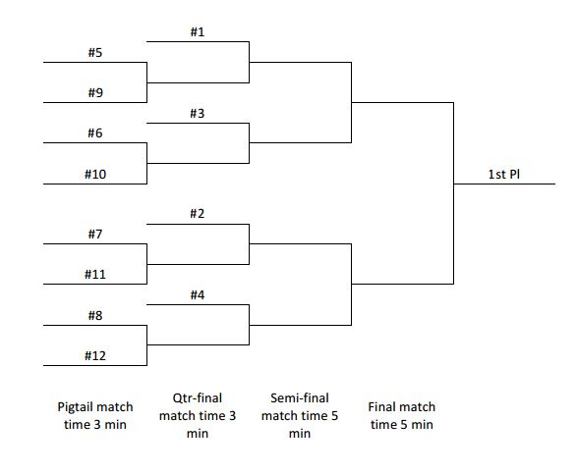
Tournament Information Contact:

Thor Metzinger
15290 Arapahoe Drive
Golden Colorado 80403
720-480-9749 (c)

Registration Deadline: April 8th, 2016

SWKIF Shinsa Registration must be done separately

All celebration dinner tickets for competitors and guests
must be pre-purchased.

No tournament refunds will be granted after 4/13/18

No T-shirt refunds will be granted after 3/30/18

Modifications to T-shirt orders must be emailed to
thormetzinger@gmail.com by 3/29/18.
All dojos commit to shirt orders effective 3/30/18

All attendees 4.Dan+ will serve as Shinpan throughout the competitions

Keikogi & hakama will be allowed for Shinpan who also participate in a team.

A Special Lunch will be provided for all Shinpan

Shinsa Registration & payments will be handled separately by the SWKIF.

Hotel to Tournament & Shinsa

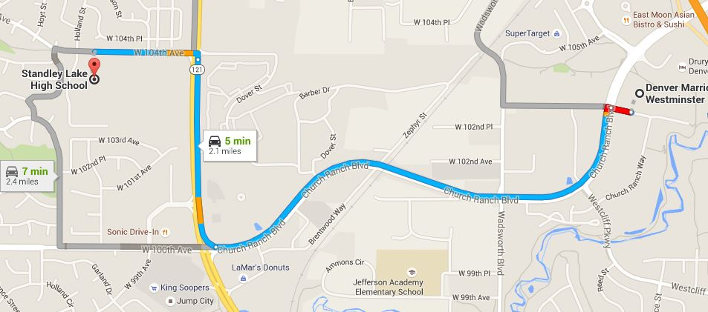
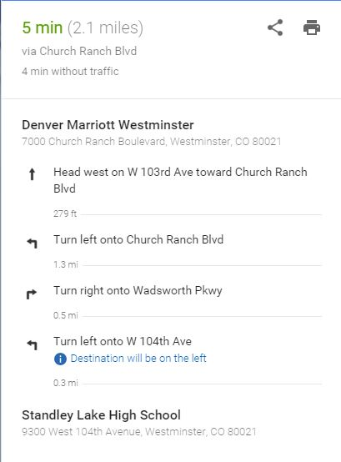

Hotel to Celebration Dinner

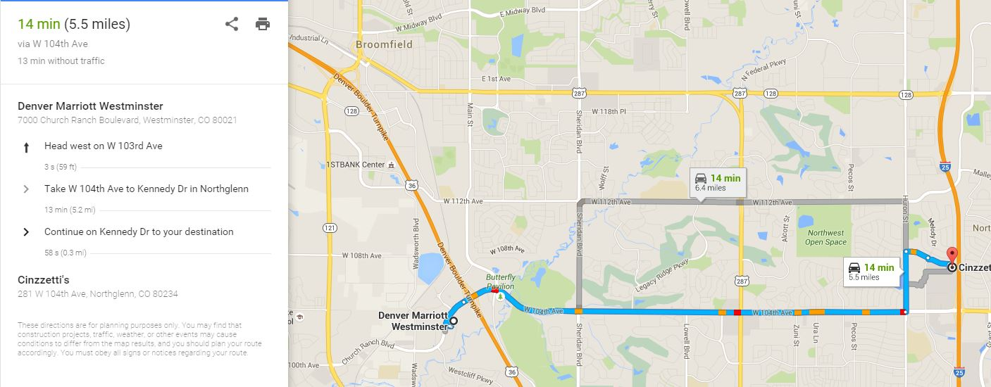

There are numerous locations to eat and drink near the hotel after the dinner.

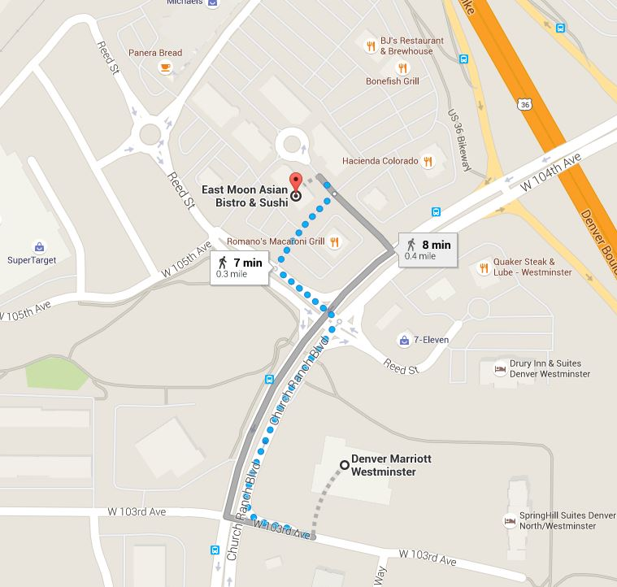

TShirts: We have selected a soft heavy cotton shirt in light gray for this year’s Ito Cup.
More size examples can be found on the website.

https://www.customink.com/g/tzm0-00ba-zhu2
